B -FLOWER PROJECT

**CONTENT OF THE TABLE**

* GITHUB REPOSITORY LINK
* WEB SITE STRUCTURE
* VALIDATIONS AND TECHNOLOGIES

1. **GITHUB REPOSITORY LINK**

[**https://github.com/NADUNSANDEEPA/suntec_interview**](https://github.com/NADUNSANDEEPA/suntec_interview)

1. **WEB SITE STRUCTURE**

This web site developed for the Flower shop. Its name is B-FLOWER. Following diagrams show system structure.

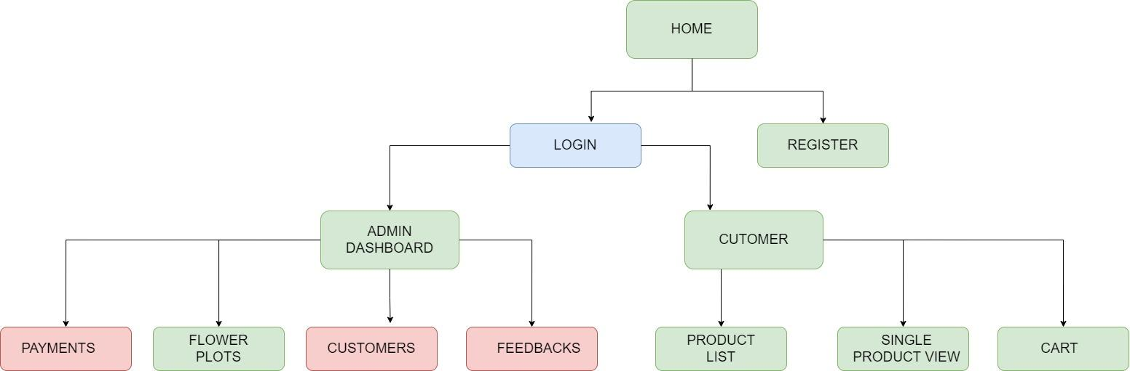

**Green Color - Completed**

**Red Color - Not Completed**

**Blue Color - Halfly Completed**

1. **VALIDATION AND TECHNOLOGIES**

* **Payhere Payment Gateway**  
  I used **payhere** as the payment gateway of the application.
* **Media Server   
  Cloudinary** is used by me to upload images.
* **Media Server   
  MySql** is used by me as the database.
* **Input Validation**  
  There are frontend input validations for below text fields. Input validations are done with redux.
  + Telephone number
  + NIC
  + Email address
  + Password
  + Confirm Password
* **Backend Password Encryption**

**BCrypt** is used for password encryption.

* **Other Forntend Libraries** 
  + Axios
  + Sweet alert 2
  + React-bootstrap-table-next (For table pagination and sorting)
  + Crypto -js
  + MD Boostrap (Frontend UI Kit)
  + JS Cookies